- Examine the table below and identify if this is a relation. Find 3 specific examples to support your answer
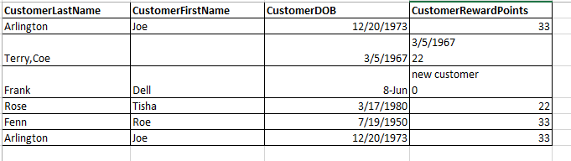
The table is not a relation
- A cell has more than a single value (Customer Last Name Terry, Cole)
- Customer DOB has a different data type.
- Customer Reward Points Holds multiple data in a single cell, and has data of the wrong data type on the 2nd, and 3rd row
- Columns customer last name and customer first name having repeated data in 1st and 6th row.

- BOOK (ISBN, Title, Publisher ID, Address)
ISBN -> (Title, PublisherID)
PublisherID -> Address
Which normal form does this example violate and how can it be fixed?
Violates == The 3NF
Fixed == PUBLISH (Publisher ID, Address)
BOOK (ISBN, Title, Publisher ID)
FK Publisher ID PUBLISH

- ORDER (OrderNumber, ProductID, Description, ShippingDate)
(OrderNumber, ProductID) ->ShippingDate
ProductID -> Description
Which normal form does this example violate and how can it be fixed?
Violates == 2NF
FIXED == PRODUCT (Product ID, Description)
ORDER (Order Number, Product ID, Shipping Date)
FK Product PRODUCT

- PART (PartID, Description, Price, ComponentID, Number)
PartID -> (Description, Price)
PartID, ComponentID -> Number
Which normal form does this example violate and how can it be fixed?
Violates == 3NF
Fixed == PART (Part ID, Description, Price)
PART AND COMPONENT (Part ID, Component ID, Number)
FK Part ID PART

- (StaffNumber, DentistName, PatientID, PatientName, AppointmentDate, AppointmentTime, SurgeryName)
StaffNumber -> (DentistName, PatientID, PatientName)
PatientID -> PatientName
(PatientID, AppointmentDate, AppointmentTime) -> SurgeryName
Which normal form does this example violate and how can it be fixed?
Violates == 3NF
Fixed == PAA (Patient ID, Appointment Date, Appointment Time, Surgery Name)
FK Patient ID Patient

PATIENT (Patient ID, Patient Name)
DENTIST (Staff Number, Dentist Name, Patient ID, Patient Name}
FK Patient ID Patient

- INTERVIEW_APPOINTMENT (InterviewID, CandidateID, CandidateName, CandidateTelephone, InterviewDate, InterviewTime, InterviewLocation, SuprevisorID, SuprevisorName, SuprevisorTelephone)
Following are the functional dependencies. Bring the relations to 3NF.
InterviewID -> (CandidateID, CandidateName, CandidateTelephone, InterviewDate, InterviewTime, InterviewLocation, SuprevisorID, SuprevisorName, SuprevisorTelephone)
CandidateID -> (CandidateName, CandidateTelephone, SuprevisorID, SuprevisorName, SuprevisorTelephone)
SupervisorID -> (SuprevisorName, SuprevisorTelephone)

Violates == 3NF
Fixed == SUPERVISOR (Supervisor ID, Supervisor Name, Supervisor Telephone)

CANDIDATE (Candidate ID, Candidate Name, Candidate Telephone, Supervisor ID, SuprevisorName, SuprevisorTelephone)
FK Supervisor ID SUPERVISOR

INTERVIEW_APPOINTMENT (Interview ID, Interview Date, Interview Time, Interview Location, Candidate ID, Supervisor ID)

FK Supervisor ID SUPERVISOR
FK Candidate ID CANDIDATE

